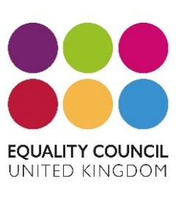

January 2020
Equality Council UK
Unit 34, Brunel Centre,
Bletchley
MK2 2ES

PRESS RELEASE

The Mayor of Milton Keynes Cllr Sam Crooks was the chief guest at Equality Council’s AGM and Diversity Awards held on 19th December 2019.

The Mayor presented NINE ‘Spotlight’s on You’ Equality Awards to community members For Making a Difference.

The youngest awardee was Jacob Joshua Bennet aged nine, for having a heart of gold for raising funds for the homeless and those in need of medical care. (profile attached)

Navrita Atwal, Chief Executive of Equality Council UK said “there are so many people doing outstanding work in the community around equality, diversity, inclusion and poverty. It is important to recognise the amazing work they are doing. We would love to hear about more individuals and organisations so we can say a BIG THANK YOU and Award them for their fabulous contribution to society. It takes having that GOLDEN HEART to ensures that those in need are loved and supported.
The aim of ECUK is to ensure that we create a society where people feel they can live, work, play, enjoy without the fear of hate crime or inequality. We are always looking to increase volunteers and members who can play a leading role in making a difference.

For further information contact
Navrita Atwal
CEO
EQUALITY COUNCIL UK
navritaa@equalitycounciluk.org
07957626985

Navrita Atwal

